Program Interfaces

Interface Summary
void | ValidatePin(int acctNo, int Pin)  Determines whether a user-specified PIN matches PIN in Account  Constraints:  The input must be all numeric – error message will be displayed if the PIN is wrong or not valid.  “Invalid PIN”
void | Credit(decimal amount)  credits the account
void | Debit(decimal amount)  debits the account-subtract from total balance – call the function BalanceInquiry()  Constraints:  The value cannot go below the minimum balance
void | Withdraw (decimal wAmount)  - get available balance of account involved  - check whether the user has enough money in the account. Calls the function  - BalanceInquiry()  - check whether the cash dispenser has enough money  - debit the account to reflect the withdrawal and records the transaction  - dispense cash  - if cash available in the dispenser and user have enough money in the account  instruct user to take cash – uses the following functions  - IsSufficientCashAvailable()  - DispenseCash()  else  display cash dispenser does not have enough cash or not enough money available in user's account  Constraints:  - user have enough money in the account  - cash dispenser have enough money.
void | BalanceInquiry ()  get the available balance for the current user's Account
void | DispenseCash (decimal amount)  simulates dispensing the specified amount of cash
void | IsSufficientCashAvailable (decimal amount)  indicates whether cash dispenser can dispense desired amount
void | FillCash (decimal amount)  Fill cash dispenser with money.
void | AuthenticateAdmin ()  Checks if the login is valid
decimal | CheckCash()  Returns total cash available in the dispenser
Dataset | TransactionHistory(string ATMNo, Datetime From, DateTime To)  Displays transaction record for a specific time period.
void | CustomerRecords(string CusID, string CusFName, string CusLName,decimal CusBalance, string AcctID,string PIN,string option)  Does creation, update, and deletion of customer records in the repository.
void | ATMRecords(string ATMNo, sting bank name, string ATMcardNo, int PIN code, string Baccount)  Stores the ATM information.
void | TransactionRecords(int TransactionID, string type,DateTime timestamp, string AccountNo, decimal TAmount)  Updates database with the transaction
void | AdminRecords(int ActionID, string AdminID, string ActionDescription)  Updates the database with the Admin activities.
Void | TransferAccount(string FromAcctID, string ToAcctID, decimal TransAmount)  Transfers the amount from the user’s account to another account.

Button Action Summary
void | mouseClicked (MouseEvent e) - AuthenticateUser  Initiates functions associated with validating pin on mouse click and if valid transfers to the Transaction Page.  Functions Called:  ValidatePin()  Constraints:  The PIN must be all numeric and maximum 6 digits. If not the following message will be displayed:  “PIN not in correct format”  “PIN doesn’t match, Please check your account number and re-enter the PIN”
void | mouseClicked (MouseEvent e) - CheckBalance  Initiates functions associated with checking available balance on mouse click and displays the available balance. Records the user action in the database.  Functions Called:  BalanceInquiry()  TransactionRecords()
void | mouseClicked (MouseEvent e) – withdraw  Initiates functions associated with withdrawal on mouse click and updates the database with amount withdrawn and the user action.  Functions Called:  Withdraw()  Transaction Records()  Constraints:  Must have sufficient balance in the account.
void | mouseClicked (MouseEvent e) - PrintReceipt  Prints the receipt with available balance and current transaction.
void | mouseClicked (MouseEvent e) – Transfer()  Initiates functions associated with transferring money from one account to another on mouse click (left or right click)  Functions Called:  BalanceInquiry()  TransferAccount()  TransactionRecords()  Constraints:  Can transfer only a specified amount per day not more than $1000.  The To account no should be valid.
void | mouseClicked (MouseEvent e) - AuthenticateAdmin  Initiates functions associated with admin authentication integer on mouse click  Functions Called:  AuthenticateAdmin()  AdminRecords()
void | mouseClicked (MouseEvent e) - CustomerRecords  Initiates functions associated with customer on mouse click. Displays a gridview with all the records and all the operations can be performed on the grid and will reflect in the database.  Functions Called:  CustomerRecords()  AdminRecords()  Constraints:  none
void | mouseClicked (MouseEvent e) - ATMRecords  Initiates functions associated with ATM information on mouse click. Displays a gridview with all the records and all the operations can be performed on the grid and will reflect in the database.  Functions Called:  ATMRecords()  AdminRecords()  Constraints:  none
void | mouseClicked (MouseEvent e) - ViewTransactionHistory  Initiates functions associated with Transaction History.  Functions Called:  TransactionHistory(ATMno, FromDate, ToDate)  AdminRecords()  Constraints:  Date valid- The from and To date must be valid
void | mouseClicked (MouseEvent e) – CheckcashDispenser  Initiates functions associated with checking cash in the dispenser.  Functions Called:  IsSufficientCashAvailable()  AdminRecords()
void | mouseClicked (MouseEvent e) – AddCash  Initiates functions associated with Adding cash in the dispenser.  Functions Called:  FillCash()  AdminRecords()  Constraints:  Only the Admin has rights to fill cash.

Code Structure

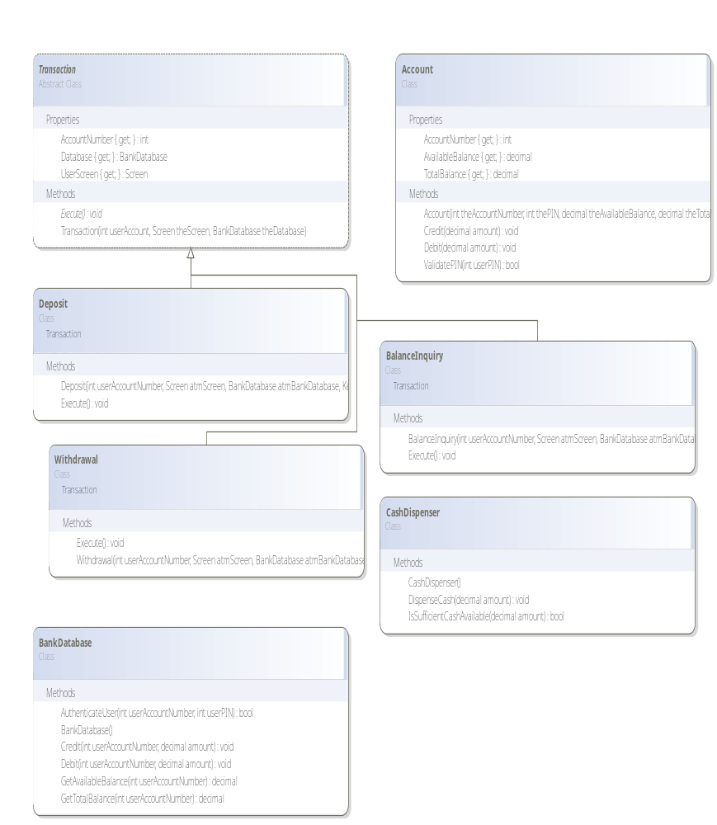
Figure 2: Class Diagram

